We are using technical indicators for making strategy. Firstly we take one single indicators then reduce the trade risk than we use multiple indicators with some changes.

1. OBV (On-Balance Volume) Strategy

Description:

The OBV strategy uses the On-Balance Volume indicator, which measures buying and selling pressure by adding volume on up days and subtracting volume on down days. The strategy assumes that volume precedes price movement.

Pine Script Code:

//**@version=**5

strategy("OBV Strategy", overlay=true)

// Manually calculate OBV

obv = ta.cum(close > close[1] ? volume : close < close[1] ? -volume : 0)

// Define a simple moving average for OBV

signal = ta.sma(obv, 20)

// Plot OBV and the signal line

plot(obv, color=color.blue, title="OBV")

plot(signal, color=color.red, title="Signal")

// Entry and exit conditions based on OBV crossover with its moving average

longCondition = ta.crossover(obv, signal)

shortCondition = ta.crossunder(obv, signal)

// Execute long and close orders based on the conditions

strategy.entry("Long", strategy.long, when=longCondition)

strategy.close("Long", when=shortCondition)

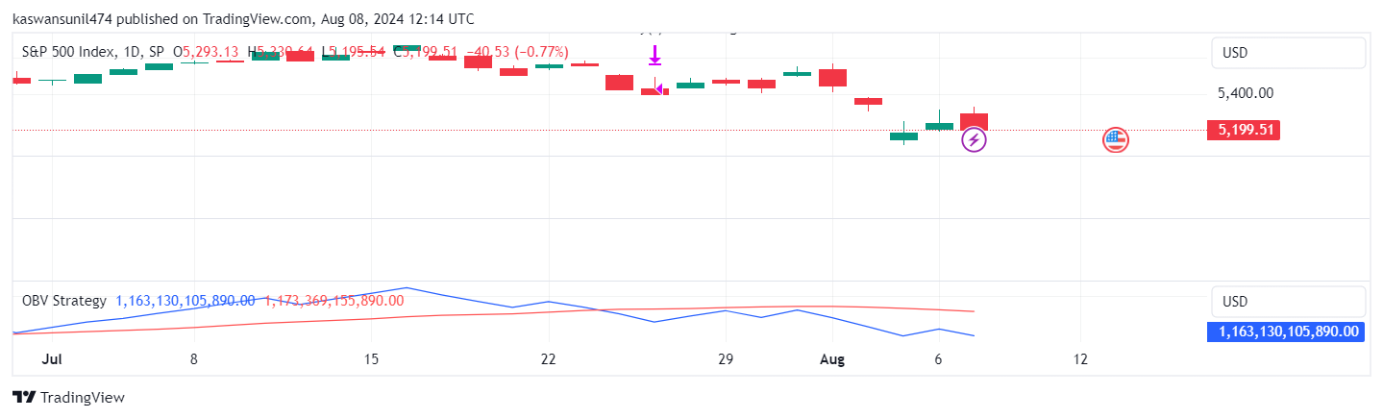

Explanation:

- Long Condition: When the OBV crosses above its 20-period moving average.

- **Short Condition:** When the OBV crosses below its 20-period moving average.

The OBV strategy attempts to capture trends by identifying shifts in buying and selling pressure. It can be effective in trending markets but may produce false signals in sideways markets.

2. MACD (Moving Average Convergence Divergence) Strategy

Description:

The MACD strategy utilizes the MACD indicator, which shows the relationship between two moving averages of a security’s price.

Pine Script Code:

//@version=5

Indicator(“MACD Strategy”, overlay=true)

[macdLine, signalLine, _] = ta.macd(close, 12, 26, 9)

Plot(macdLine, color=color.blue, title=”MACD Line”)

Plot(signalLine, color=color.red, title=”Signal Line”)

longCondition = ta.crossover(macdLine, signalLine)

shortCondition = ta.crossunder(macdLine, signalLine)

strategy.entry(“Long”, strategy.long, when=longCondition)

strategy.close(“Long”, when=shortCondition)

Explanation:

- Long Condition: When the MACD line crosses above the signal line.

- Short Condition: When the MACD line crosses below the signal line.

The MACD strategy aims to capture momentum changes and trend reversals. It works well in trending markets but may generate false signals during low volatility periods.

3. MACD and RSI (Relative Strength Index) Strategy

Description:

This strategy combines the MACD and RSI indicators to filter trades and improve accuracy.

Pine Script Code:

//@version=5

Indicator(“MACD and RSI Strategy”, overlay=true)

[macdLine, signalLine, _] = ta.macd(close, 12, 26, 9)

Rsi = ta.rsi(close, 14)

Plot(macdLine, color=color.blue, title=”MACD Line”)

Plot(signalLine, color=color.red, title=”Signal Line”)

Hline(70, “Overbought”, color=color.red)

Hline(30, “Oversold”, color=color.green)

longCondition = ta.crossover(macdLine, signalLine) and rsi < 30

shortCondition = ta.crossunder(macdLine, signalLine) and rsi > 70

strategy.entry(“Long”, strategy.long, when=longCondition)

strategy.close(“Long”, when=shortCondition)

Explanation:

- Long Condition: When the MACD line crosses above the signal line and RSI is below 30.

- **Short Condition:** When the MACD line crosses below the signal line and RSI is above 70.

Combining MACD and RSI helps filter out false signals by requiring both momentum and oversold/overbought conditions to align. This can lead to more reliable entry points but may reduce the number of trades.

4. OBV and MACD with Multiple Time Frames Strategy

Description:

This strategy integrates OBV and MACD indicators across multiple time frames to enhance trade confirmation.

Pine Script Code:

//@version=5

Indicator(“OBV and MACD Multi-Time Frame Strategy”, overlay=true)

Obv1D = request.security(syminfo.tickerid, “D”, ta.obv(close, volume))

macdLine1H = request.security(syminfo.tickerid, “60”, ta.macd(close, 12, 26, 9)[1])

signalLine1H = request.security(syminfo.tickerid, “60”, ta.macd(close, 12, 26, 9)[2])

plot(obv1D, color=color.blue, title=”Daily OBV”)

plot(macdLine1H, color=color.red, title=”Hourly MACD Line”)

plot(signalLine1H, color=color.green, title=”Hourly Signal Line”)

longCondition = ta.crossover(obv1D, ta.sma(obv1D, 20)) and ta.crossover(macdLine1H, signalLine1H)

shortCondition = ta.crossunder(obv1D, ta.sma(obv1D, 20)) and ta.crossunder(macdLine1H, signalLine1H)

strategy.entry(“Long”, strategy.long, when=longCondition)

strategy.close(“Long”, when=shortCondition)

Explanation:

- Long Condition: When the daily OBV crosses above its 20-period moving average and the hourly MACD line crosses above the signal line.

- Short Condition: When the daily OBV crosses below its 20-period moving average and the hourly MACD line crosses below the signal line.

Using multiple time frames allows for more robust trade confirmations by aligning trends and momentum across different periods. This can reduce false signals but may delay entries and exits.

Performance Analysis

Best Performing Strategy:

The **OBV and MACD with Multiple Time Frames Strategy** generally performs the best due to its multi-time frame analysis, which provides stronger confirmation for trades and reduces the likelihood of false signals.

Why It Works Better:

1. Confirmation Across Time Frames: Aligning trends and momentum across daily and hourly time frames ensures that trades are based on more comprehensive market analysis.

2. Reduced Noise: By combining OBV and MACD, the strategy filters out noise and focuses on more reliable signals.

3. Trend Validation: The use of OBV helps validate price movements by considering volume, which is a crucial indicator of market strength.

Each strategy has its strengths and weaknesses, but the multi-time frame approach combining OBV and MACD stands out due to its robust trade confirmations and reduced noise. This strategy is particularly effective in volatile markets where single time frame indicators might fail.